Cont.
Ellie is close to celebrating 3 years service, Skye has celebrated 2 years service, Sophie H is celebrating 2 years’ service, Jenna is coming on to 3 years service, Karmen and Tasha are also coming up to 2 years service as well.
Nursery improvements:
We are still dedicated to continuous improvements. We have recognised that the parent platform could be stronger in documenting the learning outcomes and updating these and this is on our improvement plan for 2026. We would be grateful for your feedback as we go through the start of the year.
The secret garden has been getting overhauled and a new fence has gone into the full & mini garden.
We are replacing the flooring in the baby room and mini moons. Paul has measured up for new windows and doors for the baby and mini moons room. We continue to be grateful for Will ‘s continuous investment in the nursery despite the financial challenges facing the economy and early years sector. It doesn’t go unnoticed and must cause a lot of additional stress and work for him.
We want to thank you for being part of our journey and for allowing us to be a part of yours. Merry Christmas and much love luck happiness and health in 2026.
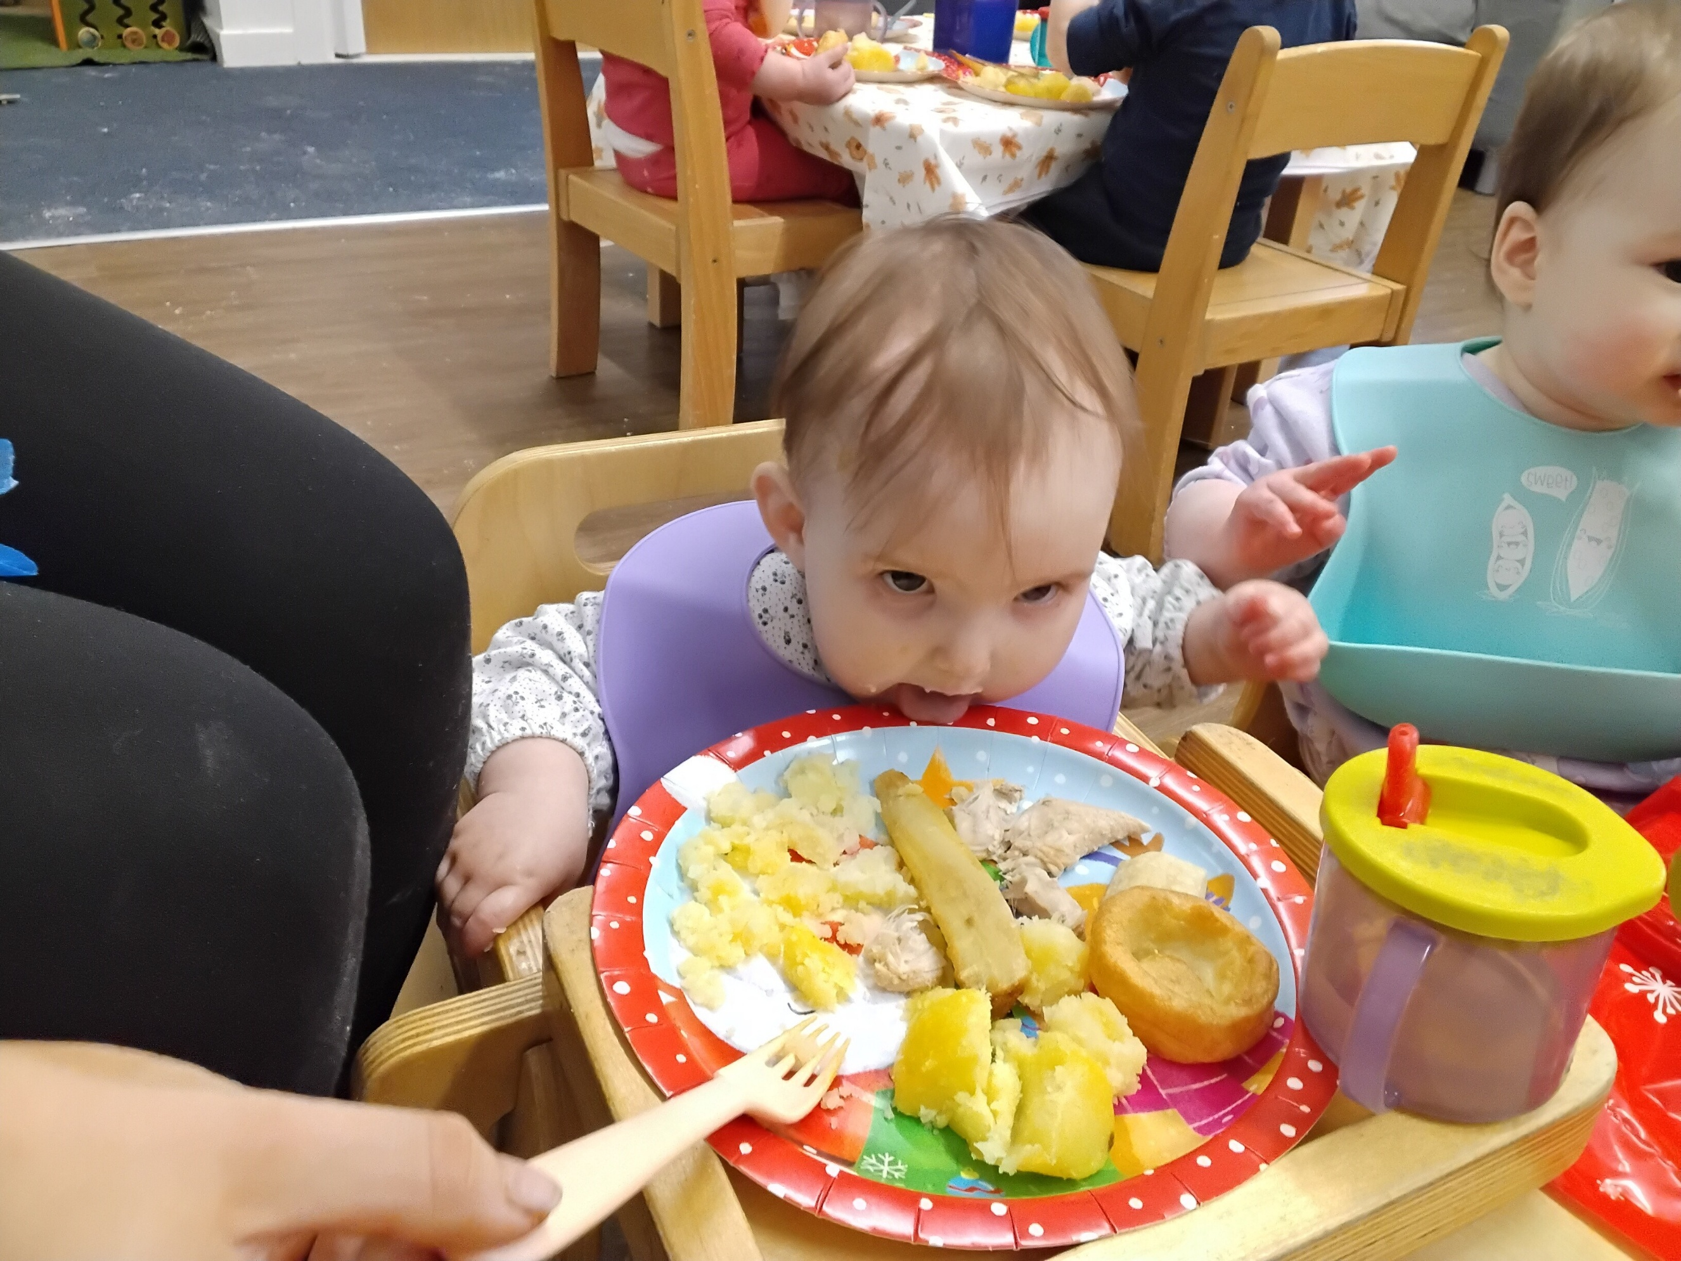
As 2025 comes to end we wanted to reflect on what we have achieved and celebrate all the families that have joined us and let us share their children memories and time.
We have been blessed with many a celebration to reflect on including:
We have remained the top rated Scottish nursery on daynurseries and have been placed in the top 20 rated Scottish nurseries for 5 consecutive years.
We were shortlisted for a 2nd year for the NDNA Nursery of the year award.
We were shortlisted by the Scottish Nursery awards for individual nursery of the year and community nursery of the year.
We won our first Midnight Moon award for Community Champion in November 2025 in which the Franchise recognised the community spirt and kindness shown by all the families who turn up, help, support and fundraise for the events throughout the calendar year. Well Done to you all.
We achieved over 90% in both Franchise audits which is or highest results since we opened.
Our Will (long suffering Managing Director) successfully and quickly set up an SQA training centre to allow us to oversea and deliver the qualification inhouse to help us raise the quality of staffing and enhance the integrity of the qualification. Terry and Will have both successfully obtained their Assessor and Internal verifier award and have started to deliver the qualification recently. This symbolises the importance our staff team has and the commitment to supporting and upskilling our team.
Will is on his final year of his BA in Childhood practice and we are so very proud of his achievements and can’t want to recognise his efforts at the end of his academic year in May 2026.
We have celebrated some staff achievements.
Sophie G has celebrated 4 years service and is on her level 4 qualification,

Article Two
Your headline can go here…………………………………. Your body copy can go here…………………………………………………………………………………………………………………………………………………………………
Article Two
Your headline can go here…………………………………. Your body copy can go here…………………………………………………………………………………………………………………………………………………………………
Article Two
Your headline can go here…………………………………. Your body copy can go here…………………………………………………………………………………………………………………………………………………………………
Banana Moon Day Bridge of Don
Whitestripes Road
Aberdeen
info@bananamoon-bridgeofdon.co.uk
We listened to your feedback and next year dates will come out shortly but not in the newsletter as they not missed by some so a separate list will follow with the dates for you all.
[Date]

